Tyler Doherty, Robert Pearson

Dr. Sarkar

CS-150

13/11/2023

Budget Manager

The goal of this project was to provide us with a way to manage your budget. We used python to create an “app” where the user inputs their income and financial information like monthly expenses. After the user inputs this information, it creates a user friendly, and easy to read budget for the user.

The context of this app is that we were given a project to create one of the options we were given. Creating a budgeting app stood out to us because a lot of Americans struggle with overspending on a variety of goods and services. Using this information, our code creates a budget for the user, taking all the work off the user’s hands and giving the user a template to go by.

The tools that we used in our coding project included classes, functions, for loops, while loops, user input, if statements, dictionaries, and lists which was ran Jupyter Notebook. With these tools we were able to create a budget manager. To start the process, we started out by planning what our budget manager could do, which included entering yearly salary, entering monthly expenses, and creation of a budget. Overall, the process included lots of trial and error along with looking through the Python coding book and our previous practice notebooks to fix errors and get inspiration. After testing over and over and many failures, we eventually refined our code and got our budget manager working.

The design of our project was set in creating a user-friendly interface and experience that is easy to learn and use. We achieved this through use of a while loop and if statements to create an interface that allowed the user to select from a few options like creating a budget or viewing their expenses. A key feature implemented throughout the project was user input, which allowed the program to run and created a budget for them. Another important thing in the code was that variables could be accessed throughout the whole program, and we did this using global variables. We did not use much advanced math, but basic math played a crucial role in calculating total expenses, monthly salary and in the creation of the sample budget.

The challenges we encountered were mostly related to just the code not working due and throwing errors. This was mostly due to typos or forgetting certain parts of the syntax, there were many times where something was misspelled, or a space was put where it should not be. The best way to avoid this is to slow down and not try and type super-fast. Another problem was with making code more complicated than it should be or trying to add a feature that was not necessary. We learned that sometimes it is better to not try and overcomplicate stuff and keep it simple.

Our project had an easy-to-navigate menu (image provided below) that allowed the user to set their salary, expenses, show expenses, and create a sample budget based on their salary. 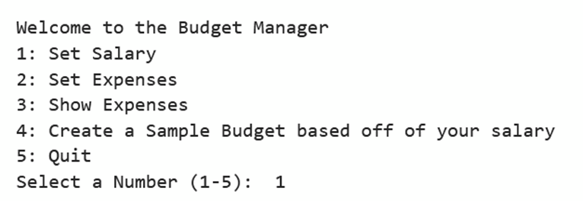

Once the user has entered their salary, they could go on to create a monthly budget based on their salary. The budget also considers if the user has debt and adjusts their budget accordingly. (pictured below)

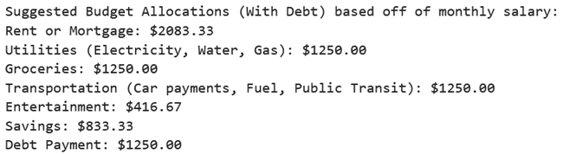

After completing our project, there were a couple of things that we could have improved on. The process for setting monthly expenses is quite tedious and if something is mistyped while working through the menu, it could throw an error. The user would also have to continue going through the menu to keep adding new expenses. It would be better if this process were more streamlined, and the expenses could be entered faster. Another thing that we could have improved would be allowing the user to enter categories for their budget so it would fit their needs instead of having broad categories. A college student’s needs for their budget will be different from those of a household.

Through this project, we were able to learn about the basics of budgeting and what people’s monthly expenses typically are. We were able to code a budgeting app that allowed users to get a sample budget based on their salary and allowed them to track their expenses. Hopefully, our project will be helpful to those who need help creating a budget.

Works Cited

“Your Guide to How to Budget Money.” *NerdWallet*, www.nerdwallet.com/article/finance/how-to-budget. Accessed 14 Nov. 2023.